**Perspective tutorial**

**What is perspective?**

Perspective is the collection of tables and views that is used to identify table and views that contain measures and dimensions.

**Where perspective folder does located or can be made?**

* For perspective you should have to first open your AOT then Data Dictionary and locate the folder “Perspective”

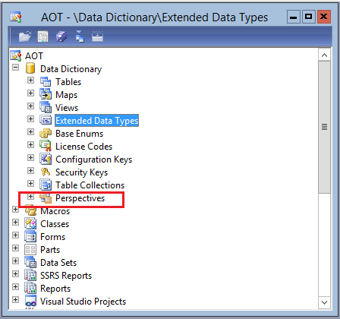

* After this if you expand the folder you see a list of perspectives that is already made.

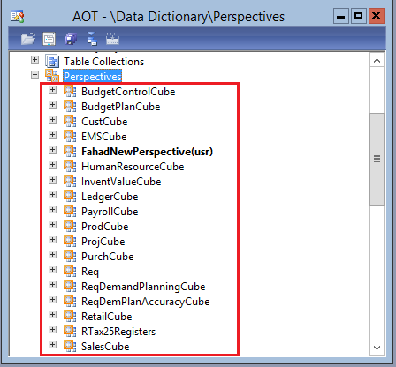

* After this right click on the perspective to create a new perspective.

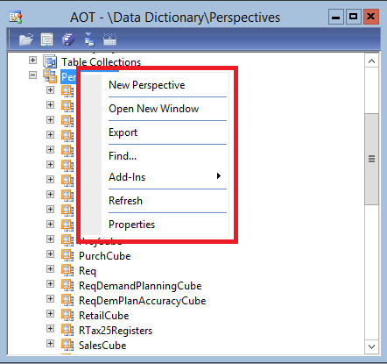

* After this when you created a new perspective it will appear in the list.

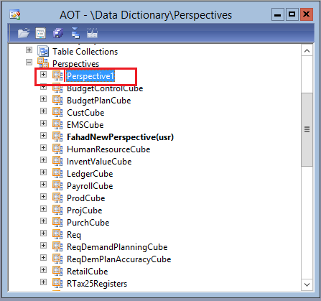

* Right click and rename it according to your requirements and it is highlighted in the below image by red rectangle.

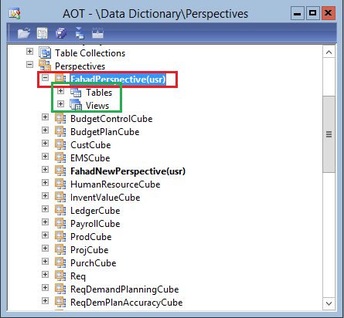

* When you expand the perspective you will see two things Tables and Views which is highlighted by green rectangle and is used to add Measures and Dimensions for OLAP.



* After this we have to drag our tables that we are going to use as dimensions and views that we made in the view part of the perspective.

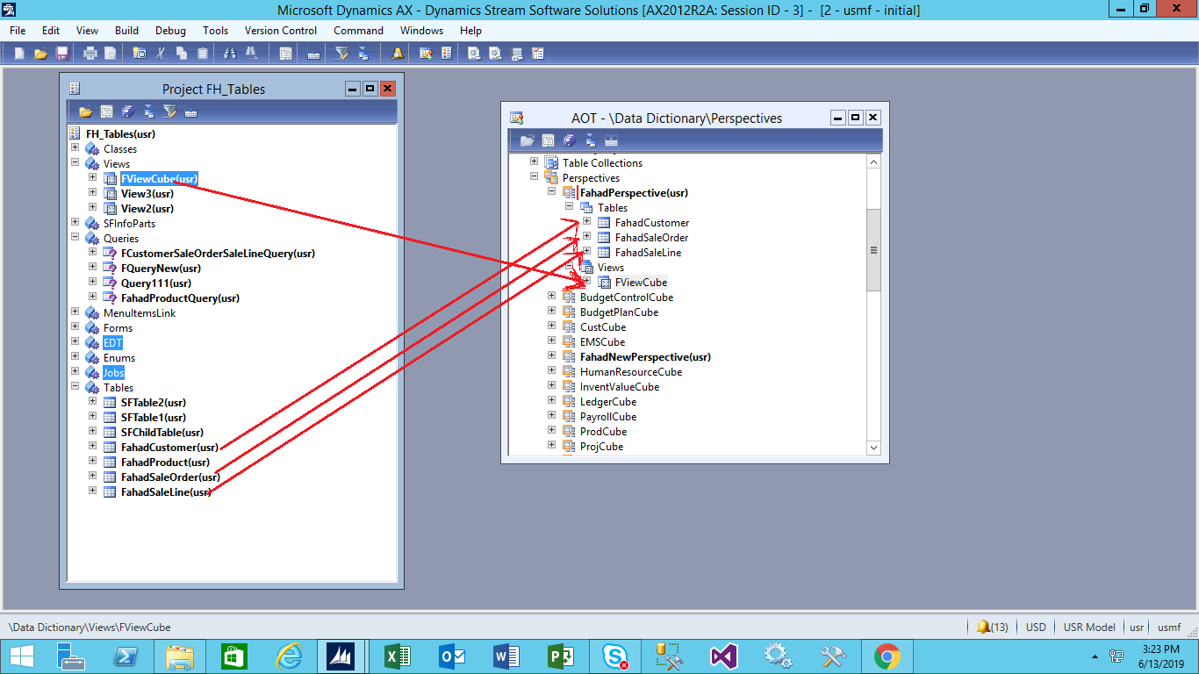

* After adding them we have to set the property of the perspective that we are going to use. So right click on the perspective and open its property and select its usage property to be OLAP as we are going to use this perspective to make cube for OLAP as shown in this diagram.

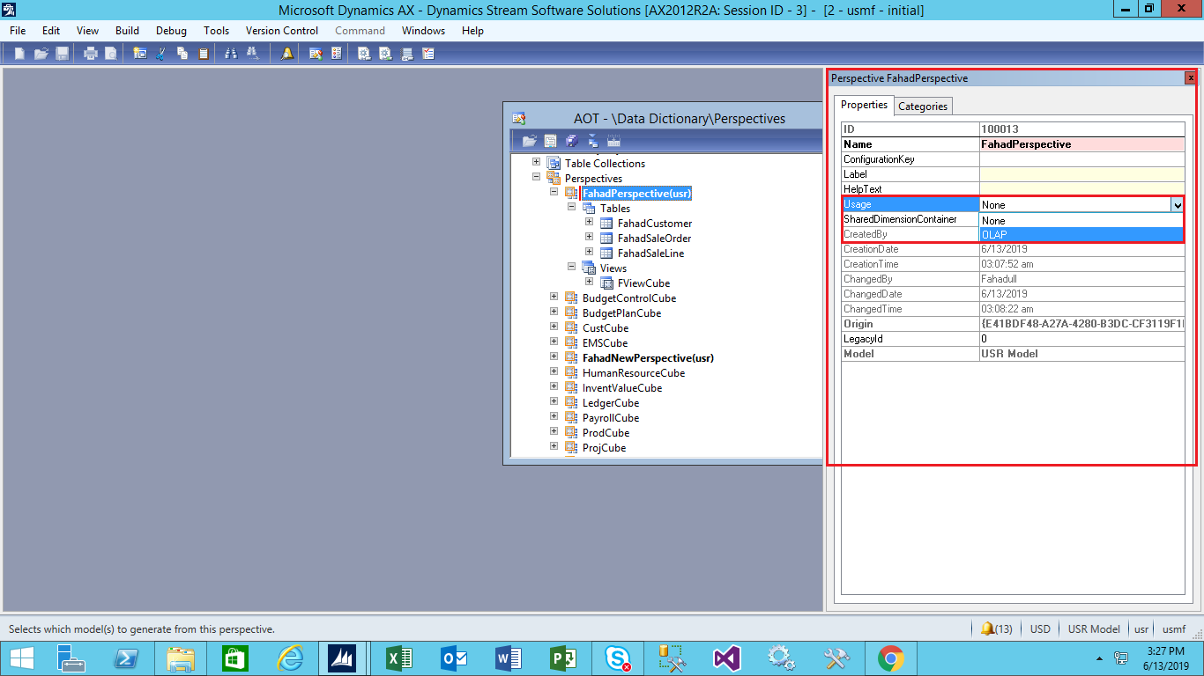

* After this we have to highlight/specify the fields whether we want to use them as Measures or as Dimensions.

**First of all first is Dimensions?**

Dimension are the descriptive features about any object. For example Customer dimension can contain First Name, Middle Name, Last Name, Contact, Address and other related information.

**What is Measure?**

Measure unlike dimension can give us numeric fact values. For example this table can contains ID's of all table or this table can be used to connect all the tables in the correct DB and it can also be known as fact table.

We can connect Dimensions and fact table by using anyone of the below mentioned schema.

1. Star schema.
2. Snow flake schema.
3. Fact constellation.

* After this you have to save your perspective.
* After saving it expand the table located in the perspective and expand any table then you will be set any property of any field.

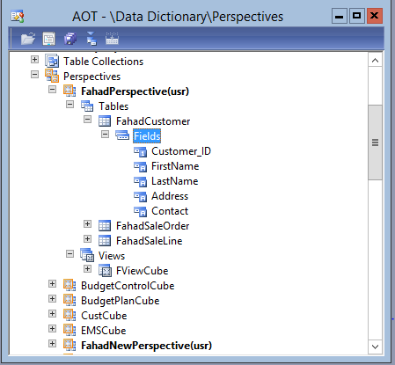

* After saving your perspective you should have to set the property of your view to be transaction as shown in the below attachment.

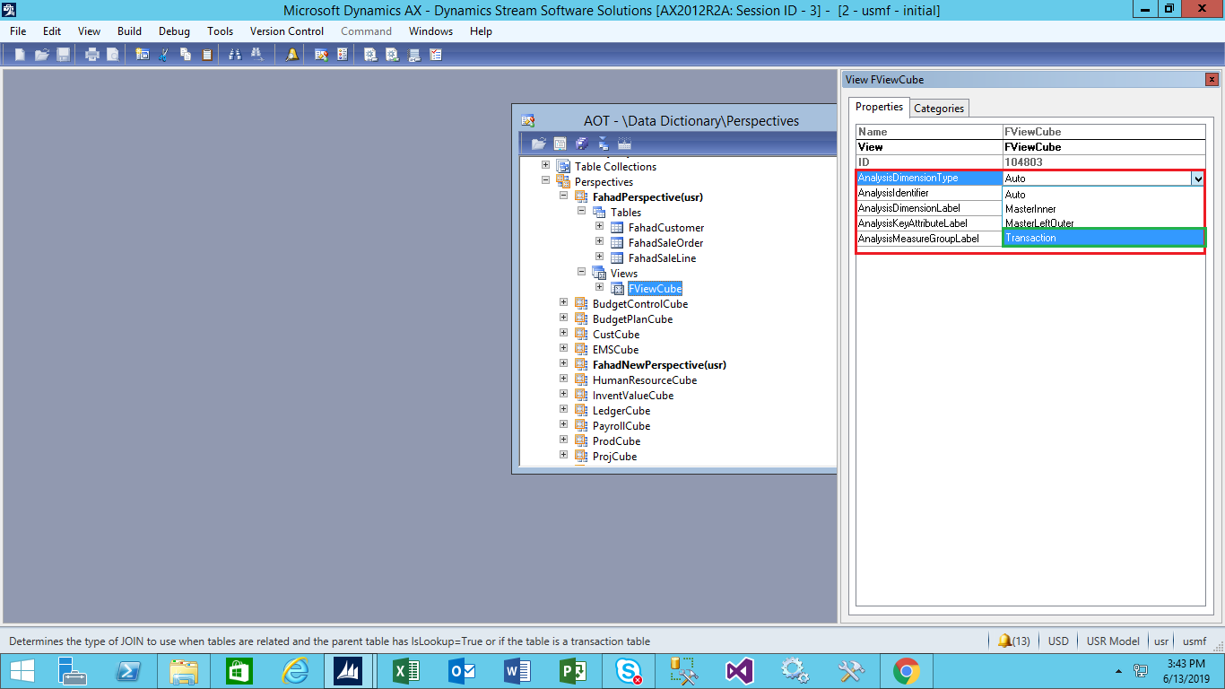

* For making any field to be Measure or attribute we should have to open the properties of that field and then select it as shown in the below image.

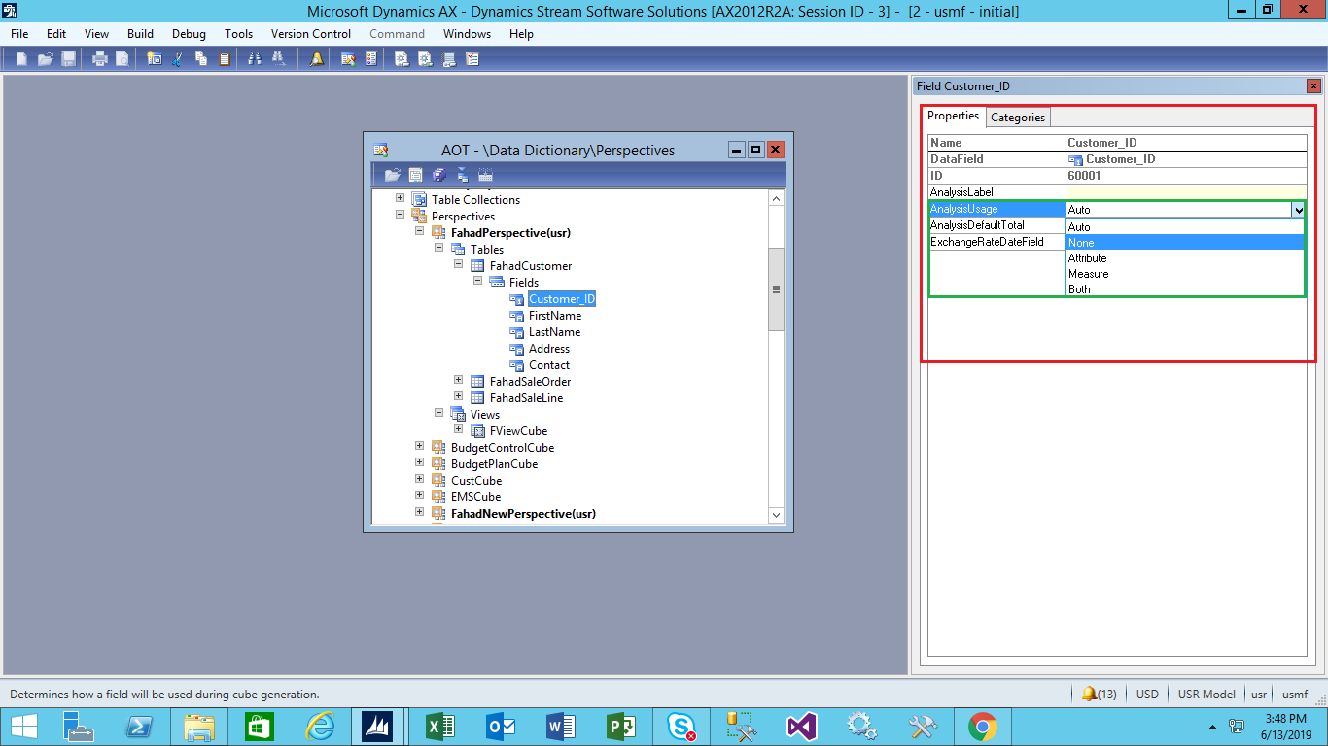

* After this you can be able to set the property AnalysisDefaultTotal in which there are some predefined operations/calculations that we will be able to use on fields. For example if we select sum then it will sum all the values of that fields.

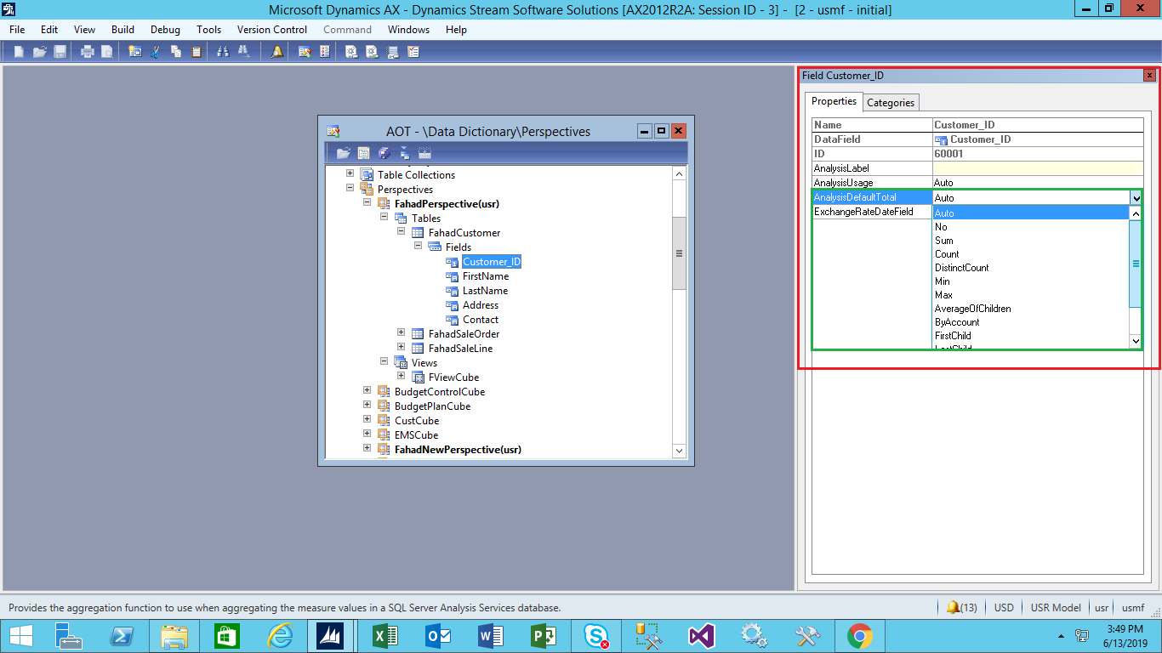

* After this save your perspective.
* Then you to make a new Business Intelligence project by going to Tools then BI and then select the SQL server analysis project.

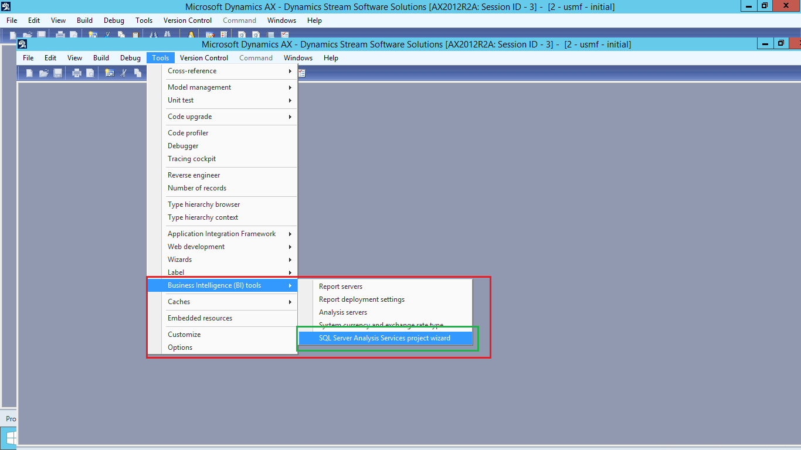

* After this a new screen open as shown below and you just have to press next button.

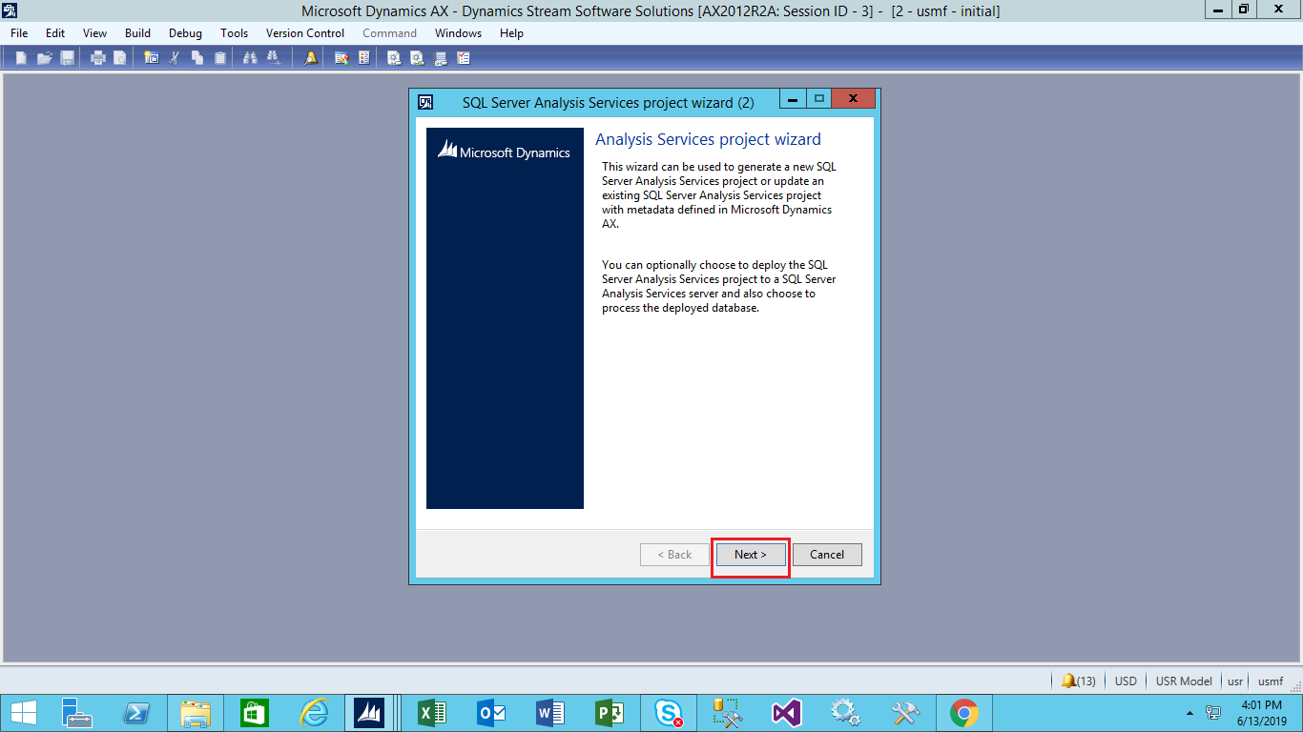

* After pressing next button another new screen open as show below in which you have to specify the name of your project and press next as shown below.

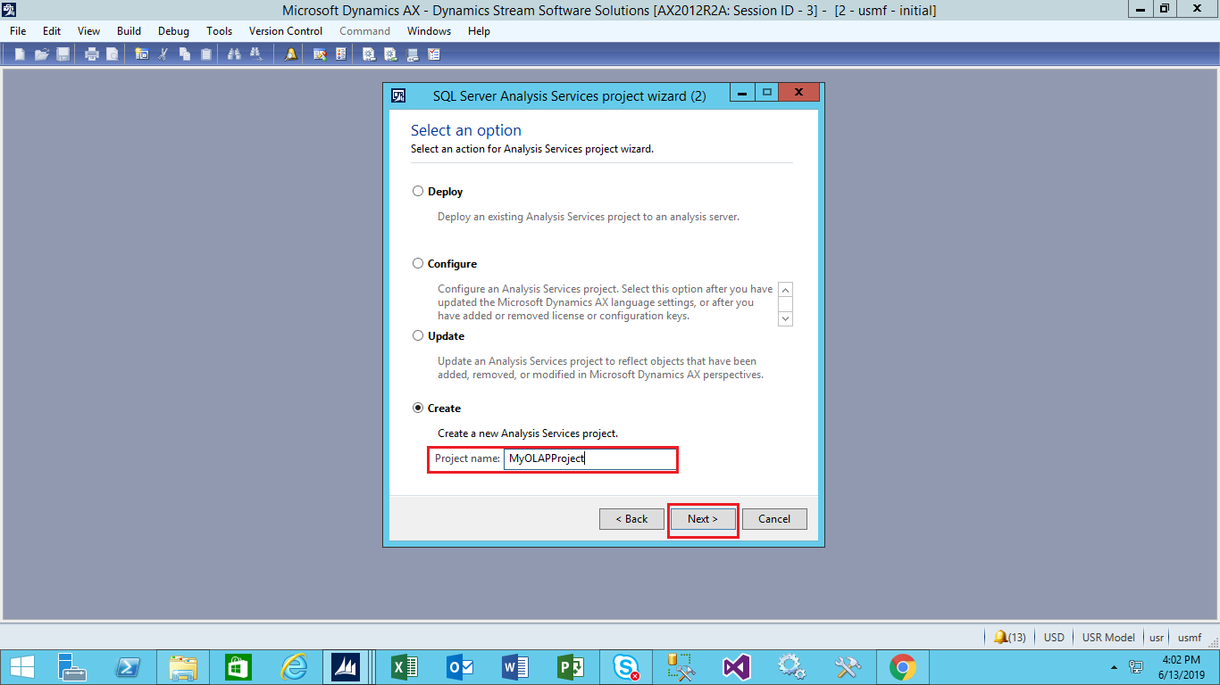

* After this a new screen open and you have to select your perspective that you have created from the list of the perspectives and then you have to press next button a new screen open.
* In this screen you have to choose dimension and it can be your own dimensions and AX predefined dimensions as well.
* After selecting it press next button another screen open in which you have to select dimension for slicing and dicing the dimension.
* Slicing and dicing is one of the functionality of the OLAP in which we can be able to view our dimension in different ways.
* After selecting any dimension press next button then a new screen open in which it prompt about language then select any appropriate language according to yourself (English(United States)).
* After selecting press next button another screen open in which a checkbox with a text (add foreign currency support) appears on that screen.
* After selecting/unselecting this feature (checkbox) press next button.
* Then it took a little while for the creation of the cube.
* After this a log appears that show whether our cube has been made successfully or not.
* Close the prompt and press finish button.
* After this another screen appears in which we have to check a check box and then select AX dynamics from the drop down as shown in the image below.

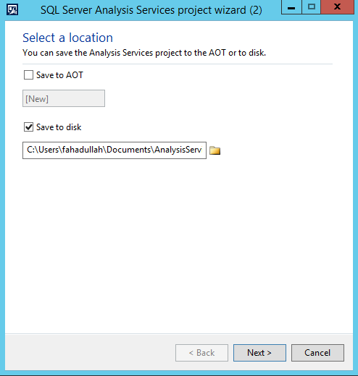

* Select AX dynamics from the list.

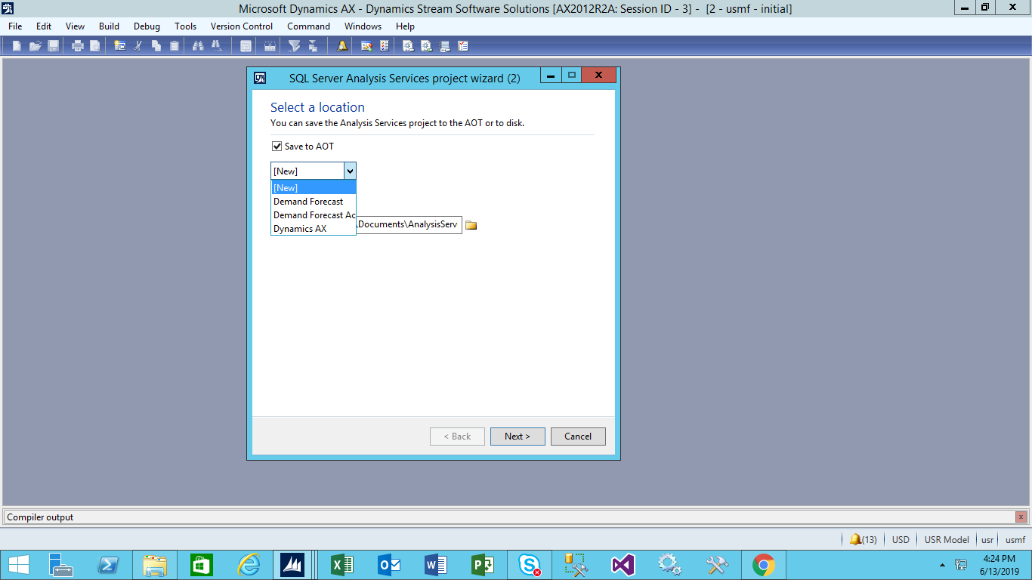

* Press next button.
* After this another screen appears in which there is a checkbox whether we want to deploy the cube after its creation.
* Then it take a little while for deploying.

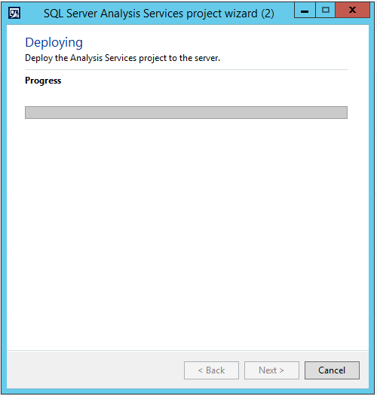

* A pop appears and your cube will successfully create and deployed.
* Then you can be to use it from SQL SERVER and Visual Studio as well for report creation by using this OLAP cube.